1. Display all female staff’s data from MsStaff.

SELECT \*

FROM MsStaff

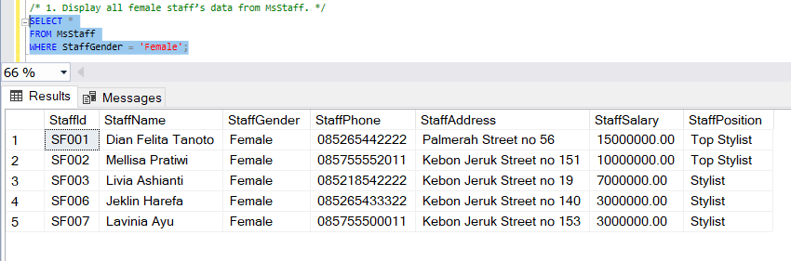WHERE StaffGender = 'Female';

2. Display StaffName, and StaffSalary(obtained by adding ‘Rp.’ In front of StaffSalary) for every staff whose name contains ‘m’ character and has salary more than or equal to 10000000. (cast, like)

SELECT StaffName,

CONCAT('Rp. ', CAST(StaffSalary AS VARCHAR)) AS [Staff Salary]

FROM MsStaff

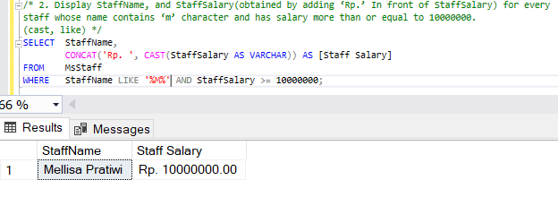WHERE StaffName LIKE '%M%' AND StaffSalary >= 10000000;

3. Display TreatmentName, and Price for every treatment which type is 'massage / spa' or 'beauty

care'. (in)

SELECT TreatmentName,

Price

FROM MsTreatment INNER JOIN MsTreatmentType ON(MsTreatment.TreatmentTypeId = MsTreatmentType.TreatmentTypeId)

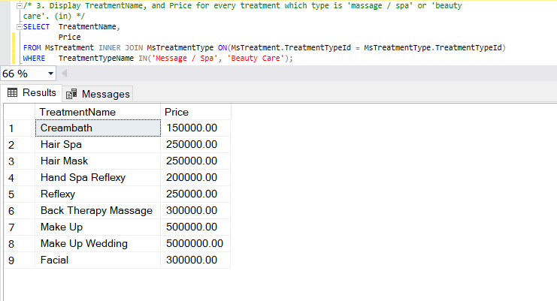WHERE TreatmentTypeName IN('Message / Spa', 'Beauty Care');

4. Display StaffName, StaffPosition, and TransactionDate (obtained from TransactionDate in Mon dd,yyyy format) for every staff who has salary between 7000000 and 10000000. (convert, between)

SELECT StaffName,

StaffPosition,

CONVERT(VARCHAR, TransactionDate, 107) AS TransactionDate

FROM MsStaff INNER JOIN HeaderSalonServices ON(MsStaff.StaffId = HeaderSalonServices.StaffId)

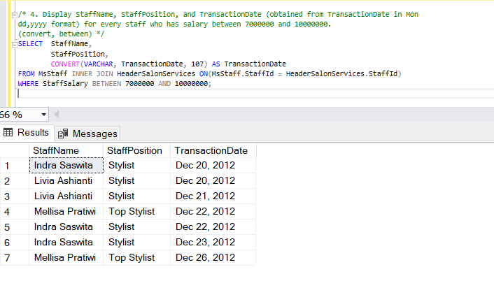WHERE StaffSalary BETWEEN 7000000 AND 10000000;

5. Display Name (obtained by taking the first character of customer’s name until character before space), Gender (obtained from first character of customer’s gender), and PaymentType for every transaction that is paid by ‘Debit’.

SELECT DISTINCT CASE CHARINDEX(' ',MsCustomer.CustomerName) WHEN 0 THEN MsCustomer.CustomerName

ELSE LEFT(MsCustomer.CustomerName, CHARINDEX(' ', MsCustomer.CustomerName))

END AS [Name],

LEFT(CustomerGender,1) AS Gender,

PaymentType

FROM MsCustomer INNER JOIN HeaderSalonServices ON(MsCustomer.CustomerId = HeaderSalonServices.CustomerId)

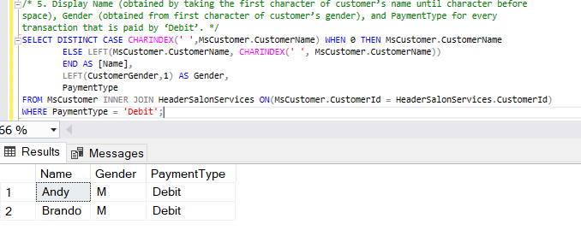WHERE PaymentType = 'Debit';

6. Display Initial (obtained from first character of customer’s name and followed by first character of customer’s last name in uppercase format), and Day (obtained from the day when transaction happened ) for every transaction which the day difference with 24th December 2012 is less than 3 days. (upper, left, substring, charindex, datename, weekday, datediff, day)

SELECT CASE CHARINDEX(' ',MsCustomer.CustomerName) WHEN 0 THEN LEFT(CustomerName,1)

ELSE UPPER(CONCAT(LEFT(CustomerName,1),SUBSTRING(CustomerName,CHARINDEX(' ',CustomerName)+1,1)))

END AS Initial,

DATENAME(WEEKDAY,TransactionDate) AS [Day]

FROM MsCustomer INNER JOIN HeaderSalonServices ON(MsCustomer.CustomerId = HeaderSalonServices.CustomerId)

WHERE DATEDIFF(DAY,TransactionDate,'2012/12/24') < 3;

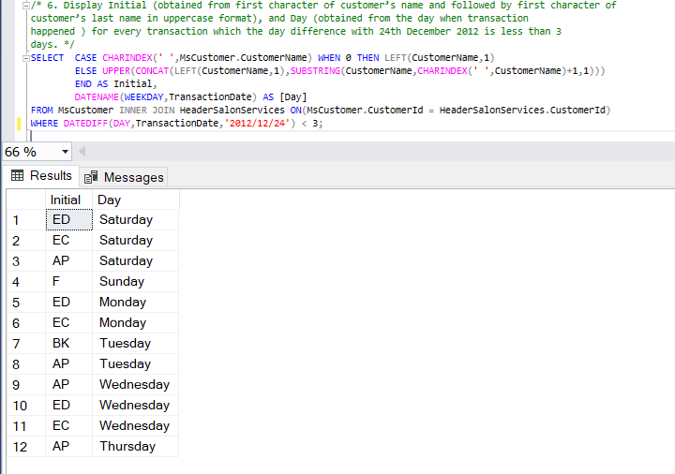

7. Display TransactionDate, and CustomerName (obtained by taking the character after space until the last character in CustomerName) for every customer whose name contains space and did the transaction on Saturday.

SELECT TransactionDate,

RIGHT(CustomerName,CHARINDEX(' ',REVERSE(CustomerName))) AS CustomerName

FROM MsCustomer INNER JOIN HeaderSalonServices ON(MsCustomer.CustomerId = HeaderSalonServices.CustomerId)

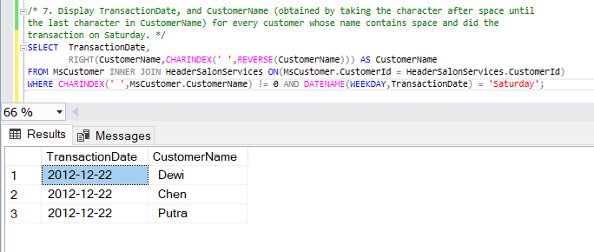WHERE CHARINDEX(' ',MsCustomer.CustomerName) != 0 AND DATENAME(WEEKDAY,TransactionDate) = 'Saturday';

8. Display StaffName, CustomerName, CustomerPhone (obtained from customer’s phone by replacing ‘0’ with ‘+62’), and CustomerAddress for every customer whose name contains vowel character and handled by staff whose name contains at least 3 words.

SELECT StaffName,

CustomerName,

CONCAT(REPLACE(LEFT(CustomerPhone,1),'0','+62'), SUBSTRING(CustomerPhone,2,LEN(CustomerPhone))) AS CustomerPhone,

CustomerAddress

FROM MsCustomer

INNER JOIN HeaderSalonServices ON MsCustomer.CustomerId = HeaderSalonServices.CustomerId

INNER JOIN MsStaff ON HeaderSalonServices.StaffId = MsStaff.StaffId

WHERE CustomerName LIKE '%[aiueo]%' AND

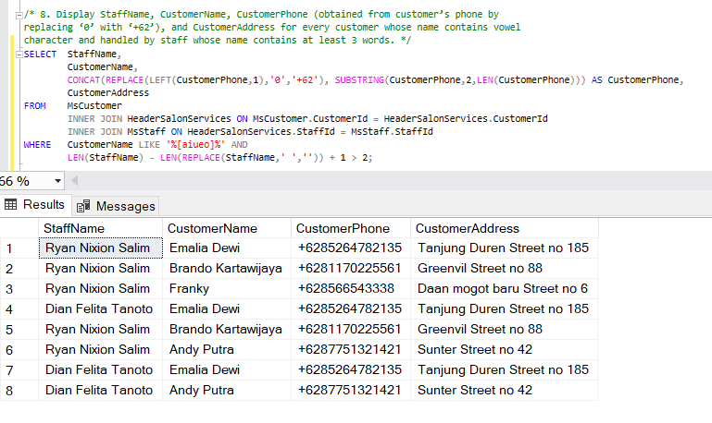 LEN(StaffName) - LEN(REPLACE(StaffName,' ','')) + 1 > 2;

9. Display StaffName, TreatmentName, and Term of Transaction (obtained from the day difference between transactionDate and 24th December 2012) for every treatment which name is more than 20 characters or contains more than one word.

SELECT StaffName,

TreatmentName,

ABS(DATEDIFF(DAY,TransactionDate,'2012/12/24')) AS [Term of Transaction]

FROM MsStaff

INNER JOIN HeaderSalonServices ON MsStaff.StaffId = HeaderSalonServices.StaffId

INNER JOIN DetailSalonServices ON HeaderSalonServices.TransactionId = DetailSalonServices.TransactionId

INNER JOIN MsTreatment ON DetailSalonServices.TreatmentId = MsTreatment.TreatmentId

WHERE LEN(TreatmentName) > 20 OR

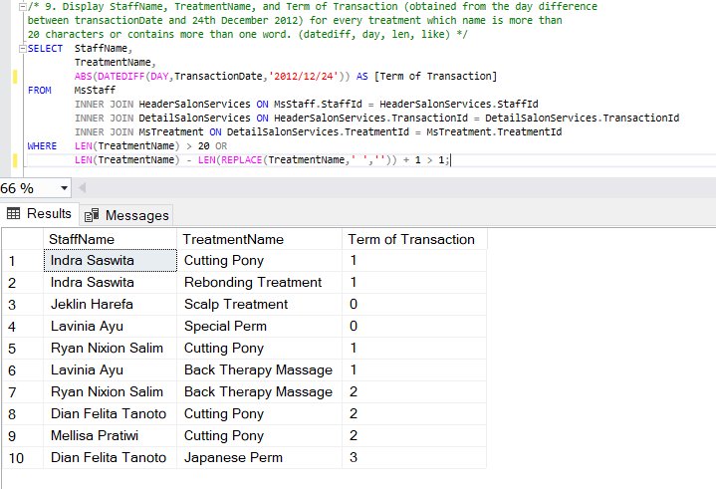 LEN(TreatmentName) - LEN(REPLACE(TreatmentName,' ','')) + 1 > 1;

10. Display TransactionDate, CustomerName, TreatmentName, Discount (obtainedby changing Price data type into int and multiply it by 20%), and PaymentType for every transaction which happened on 22th day.

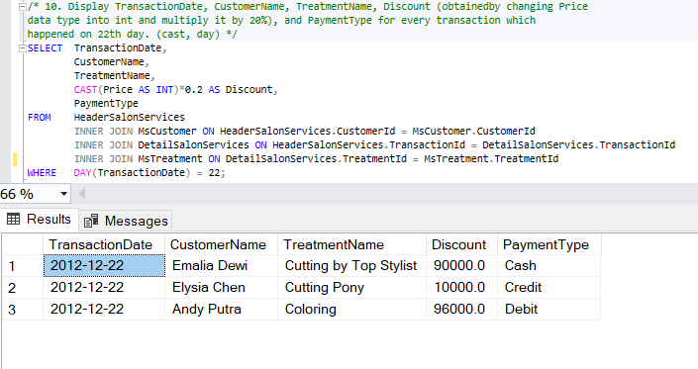SELECT TransactionDate,

CustomerName,

TreatmentName,

CAST(Price AS INT)\*0.2 AS Discount,

PaymentType

FROM HeaderSalonServices

INNER JOIN MsCustomer ON HeaderSalonServices.CustomerId = MsCustomer.CustomerId

INNER JOIN DetailSalonServices ON HeaderSalonServices.TransactionId = DetailSalonServices.TransactionId

INNER JOIN MsTreatment ON DetailSalonServices.TreatmentId = MsTreatment.TreatmentId

WHERE DAY(TransactionDate) = 22;